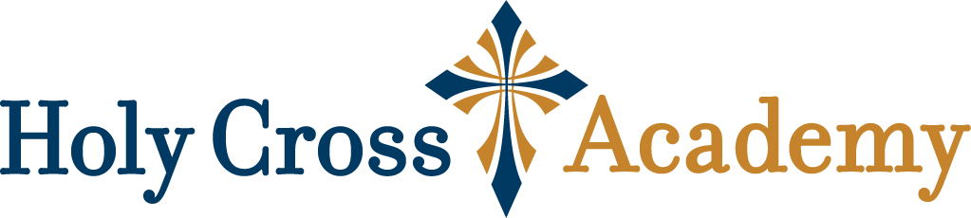**Holy Cross Academy Legacy Gala & Auction**

**Saturday, November 8, 2025**

**Auction Program Advertisement Form**

| Company or  Individual Name: |  |
| --- | --- |
| Contact Name: |  |
| Phone Number: |  |
| Address: |  |
| City, State, Zip: |  |
| E-Mail: |  |

**Auction Program Advertisement Options:**

Full Page $150 (8.5” Wx11” H)

Half Page $75 (8.5” Wx5.5” H)

Quarter Page $50 (4.25” Wx5.5” H)

**Please submit this form, payment, and design by October 10, 2025.** Checks are made payable and mailed to:

Holy Cross Academy, Attn: HCA Gala

8874 Pardee Road

St. Louis, MO 63123

To pay by Credit Card or to Wire your donation, please contact HCA’s business manager, Kelly Klosowski at 314-475-3436.

The design should be emailed to legacygala@hca-stl.org. The artwork needs to be in a high-resolution format (pdf or jpeg).

**Thank you for supporting the students of Holy Cross Academy!**